Title/Serial Number: HTOC—Finnish IP Address Previously Used by Russian SVR Midnight Blizzard Seen in Observations for Two HTOC Partners, March 2025/I&W-20250331-1043-A

Executive Summary:

65.21.203[.]39 resolves to Finland under ASN 24940 (Hetzner Online GmbH), with reverse DNS resolution to suspicious domains with self-issued certificates mail.mynymbox[.]xyz and mynymbox[.]xyz. According to AlienVault OTX, 65.21.203[.]39 is suspicious and has ports 21/FTP, 25/SMTP, 53/DNS, 80/HTTP, 110/POP3, 143/IMAP, 443/HTTPS, 587/SMTP, 993/IMAP-SSL, 995/POP3-SSL, 2222/Rockwell CSP2/EtherNet IP IO/msantipiracy/ESET Remote Administrator, 10000/BitTornado/Gaming/Viatalk/SecureNet Pro IDS Management/Network Data Management Protocol, and 20000/Distributed Network Protocol/ICQ/Viatalk open. Four security vendors label 65.21.203[.]39 as a malicious node in VirusTotal. According to Mandiant, 65.21.203[.]39 is possibly benign; however it was previously used by Russian Foreign Intelligence Service (SVR) threat actor Midnight Blizzard between 20 May 2024 and 13 January 2025. According to Pulsedive, 65.21.203[.]39 is a high risk indicator because it has a self-issued and suspicious SSL certificate and redirects to critical threat URL hxxps=//65[.]21[.]203[.]39/. Pulsedive provides the below screenshot for 65.21.203[.]39.

(Analyst Comment: Even though 65.21.203[.]39 was previously used by Russia’s Midnight Blizzard between 20 May 2024 and 13 January 2025, 65.21.203[.]39 is not exclusive to Midnight Blizzard, and may be used by other unidentified threat actors.)

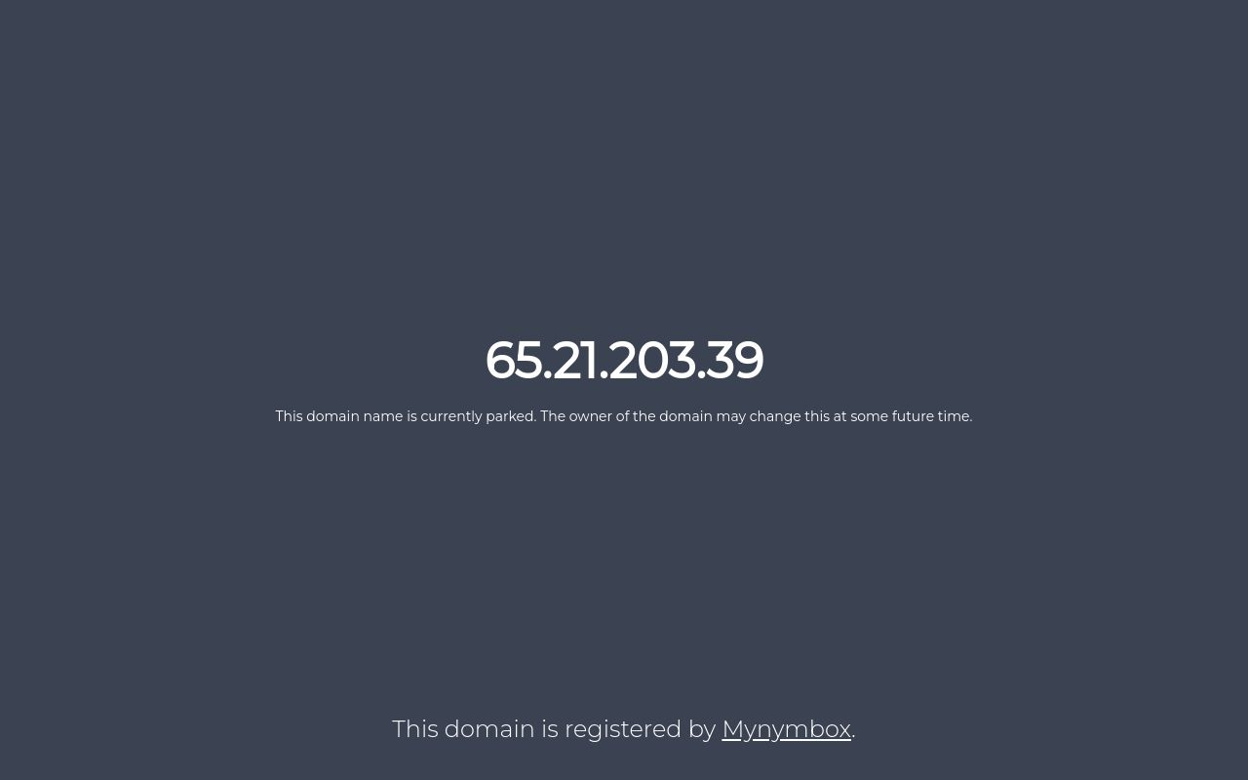

On 28 and 31 March 2025, an indicator previously used by Russian SVR Midnight Blizzard was observed across two HTOC partner networks: IHS and VA.

Technical Details:

The indicator observed at two HTOC partner networks:

Indicators/Identifiers | IndicatorType | Date Observed | Observed By | Notes
65.21.203[.]39 | IPv4 Address | 03/28/2025  03/31/2025 | IHS  VA | IP was previously used by Russian SVR’s Midnight Blizzard from 20 May 2024 to 13 January 2025.

These reported observations are indicative of the indicator being detected within the observed entity's security logs. Observations do not take into account any blocking actions or other mitigating controls, and are not proof of infection or compromise. HTOC recommends this observation be investigated to determine if associated with malicious activity or related to the previously reported malicious activity correlated to the indicator.

Sources:

https://hvs.threatconnect.com/auth/indicators/details/address.xhtml?address=65.21.203.39
https://otx.alienvault.com/indicator/ip/65.21.203.39/
https://otx.alienvault.com/indicator/hostname/mail.mynymbox.xyz
https://otx.alienvault.com/indicator/domain/mynymbox.xyz
https://www.virustotal.com/gui/ip-address/65.21.203.39/details
https://advantage.mandiant.com/indicator/ipv4/65.21.203.39
https://advantage.mandiant.com/actors/threat-actor--4701e37c-4a30-57e8-bf5d-0180b73a5575#indicators
https://pulsedive.com/indicator/?ioc=NjUuMjEuMjAzLjM5
https://pulsedive.com/explore/?q=dom.screenshot%3D2eca0f7f7307c8108127270ec2400489.jpeg
https://pulsedive.com/indicator/?ioc=aHR0cHM6Ly82NS4yMS4yMDMuMzkv

